
Erasmus+ Programme
Key Action 1
- Mobility for learners and staff -
Higher Education Student and Staff Mobility

Inter-institutional agreement 2014-20/21
between programme countries
The institutions named below agree to cooperate for the exchange of students and/or staff in the context of the Erasmus+ programme. They commit to respect the quality requirements of the Erasmus Charter for Higher Education in all aspects related to the organisation and management of the mobility, in particular the recognition of the credits awarded to students by the partner institution.
A. Information about higher education institutions
Name of the institution  (and department, where relevant) | Erasmus code | Contact details  (email, phone) | Website  (e.g. of the course catalogue)
Pädagogische Hochschule Steiermark (PHSt)  University College of Teacher Education Styria (PHSt) | A GRAZ04 | Mag. Susanne Linhofer  Head of Institute of Diversity Management and International Relations  Ortweinplatz 1, 8010 Graz, Austria  T.: +43 (0)316/8067-6601  susanne.linhofer@phst.at | www.phst.at/
B. Mobility numbers per academic year
The partners commit to amend the table below in case of changes in the mobility data by no later than the end of January in the preceding academic year.
FROM  [Erasmus code of the sending institution] | TO  [Erasmus code of the receiving institution] | Subject area code *  [ISCED] | Subject area name * | Study cycle  [short cycle, 1st , 2nd or 3rd] * | Number of student mobility periods
 |  |  |  |  | Total number of students | Total number of months
A GRAZ04 |  | 011 | Teacher training and Education Science | 1/2 | 2 | 10
 | A GRAZ04 | 011 | Teacher training and Education Science | 1/2 | 2 | 10
[*Optional: Though subject area code & name and study cycle are optional, the specification of the number of students/staff is requested. Inter-institutional agreements are not compulsory for Student Mobility for Traineeships or Staff Mobility for Training.
FROM  [Erasmus code of the sending institution] | TO  [Erasmus code of the receiving institution] | Subject area code *  [ISCED] | Subject area name * | Number of staff mobility periods
 |  |  |  | Staff Mobility for Teaching | Staff Mobility for Training *
 |  |  |  | Total number of days of teaching period | Total number of days of training period
A GRAZ04 |  | 011 | Teacher training and Education Science | 1  (5 days) | 1  (5 days)
 | A GRAZ04 | 011 | Teacher training and Education Science | 1  (5 days) | 1  (5 days)

[*Optional: subject area code & name and study cycle are optional. Total duration in months/days of the student/staff mobility periods or average duration can be indicated if relevant.]

C. Recommended language skills
The sending institution, following agreement with the receiving institution, is responsible for providing support to its nominated candidates so that they can have the recommended language skills at the start of the study or teaching period:
Receiving institution | Language | Language | Recommended language of instruction level
[Erasmus code] | of instruction 1 | of instruction 2 | Student Mobility for Studies  [Minimum recommended level: B1] | Staff Mobility for Teaching  [Minimum recommended level: B2]
A GRAZ04 | German | English (limited courses) | B1 | B2
For more details on the language of instruction recommendations, see the course catalogue of each institution [Links provided on the first page].
D. Additional requirements
A GRAZ04:
Additional requirements at the University of Teacher Education in Styria:
Welcome Days are compulsory for incoming students.
Winter term - Beginning of October
Summer term - End of February
Buddy-System for incoming students
Come2Graz - International Week for incoming staff: Second or third week of May each year.
Wheelchair accessible campus

Partnerinstitution:

[To be completed if necessary, other requirements may be added on academic or organisational aspects, e.g. the selection criteria for students and staff; measures for preparing, receiving and integrating mobile students and/or staff]

E. Calendar
1. Applications/information of nominated students must reach the receiving institution

Receiving institution  [Erasmus code] | Autumn term*  [month] | Spring term*  [month]
A GRAZ04 | 15. April | 15. November
[* to be adapted in case of a trimester system]
2. The receiving institution will send its decision within 4 weeks.
3. A Transcript of Records will be issued by the receiving institution no later than 5 weeks after the assessment period has finished at the receiving HEI.
4. Termination of the agreement
This bilateral agreement may be amended by mutual written consent of the two parties during the agreement period. In the event of unilateral termination, a notice of at least one academic year should be given. This means that a unilateral decision to discontinue the exchanges notified to the other party by 1. September 20XX will only take effect as of 1. September 20XX+1. Neither the European Commission nor the National Agencies can be held responsible in case of a conflict.
F. Information
1. Grading systems of the institutions
A GRAZ04:
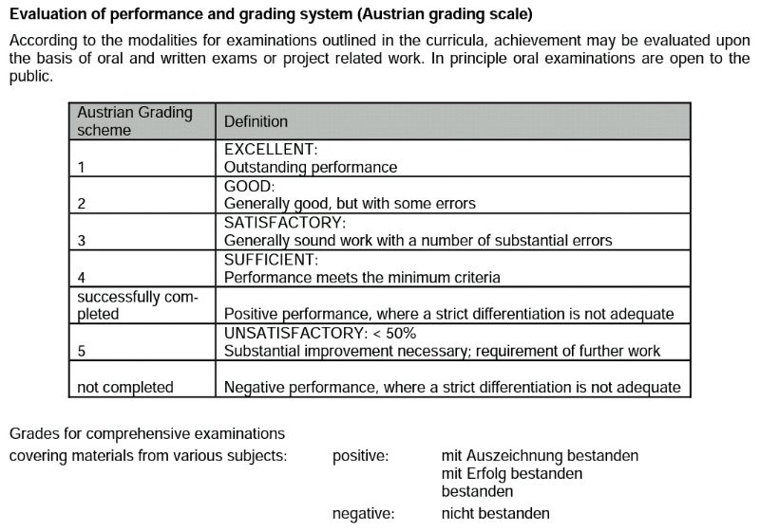
Source: Federal Ministry of Science and Research, UnitII/7, Nov. 2011

Partnerinstitution:

2. Visa
The sending and receiving institutions will provide assistance, when required, in securing visas for incoming and outbound mobile participants, according to the requirements of the Erasmus Charter for Higher Education.
Information and assistance can be provided by the following contact points and information sources:
Institution  [Erasmus code] | Contact details  (email, phone) | Website for information
A GRAZ04 | Institute of Diversity Management and International Relations  Ortweinplatz 1, 8010 Graz, Austria  T.: +43 (0)316/8067-6603  international@phst.at | www.phst.at

3. Insurance
The sending and receiving institutions will provide assistance in obtaining insurance for incoming and outbound mobile participants, according to the requirements of the Erasmus Charter for Higher Education.
The receiving institution will inform mobile participants of cases in which insurance cover is not automatically provided. Information and assistance can be provided by the following contact points and information sources:
Institution  [Erasmus code] | Contact details  (email, phone) | Website for information
A GRAZ04 | Institute of Diversity Management and International Relations  Ortweinplatz 1, 8010 Graz, Austria  T.: +43 (0)316/8067-6603  international@phst.at | www.phst.at
 |  | 55

4. Housing
The receiving institution will guide incoming mobile participants in finding accommodation, according to the requirements of the Erasmus Charter for Higher Education.
Information and assistance can be provided by the following persons and information sources:
Institution  [Erasmus code] | Contact details  (email, phone) | Website for information
A GRAZ04 | Institute of Diversity Management and International Relations  Ortweinplatz 1, 8010 Graz, Austria  T.: +43 (0)316/8067-6603  international@phst.at | www.phst.at

G. SIGNATURES OF THE INSTITUTIONS (legal representatives)

Institution  [Erasmus code] | Name, function | Date | Signature
A GRAZ04 | Mag. Dr. Elgrid Messner  Rector

Inter-institutional agreements can be signed by two or more higher education Institutions
Higher Education Institutions have to agree on the period of validity of this agreement
Contact details to reach the senior officer in charge of this agreement and of its possible updates.
Mobility numbers can be given per sending/receiving institutions and per education field (optional*: http://www.uis.unesco.org/Education/Pages/international-standard-classification-of-education.aspx)
For an easier and consistent understanding of language requirements, use of the Common European Framework of Reference for Languages (CEFR) is recommended, see http://europass.cedefop.europa.eu/en/resources/european-language-levels-cefr
Scanned signatures are accepted

